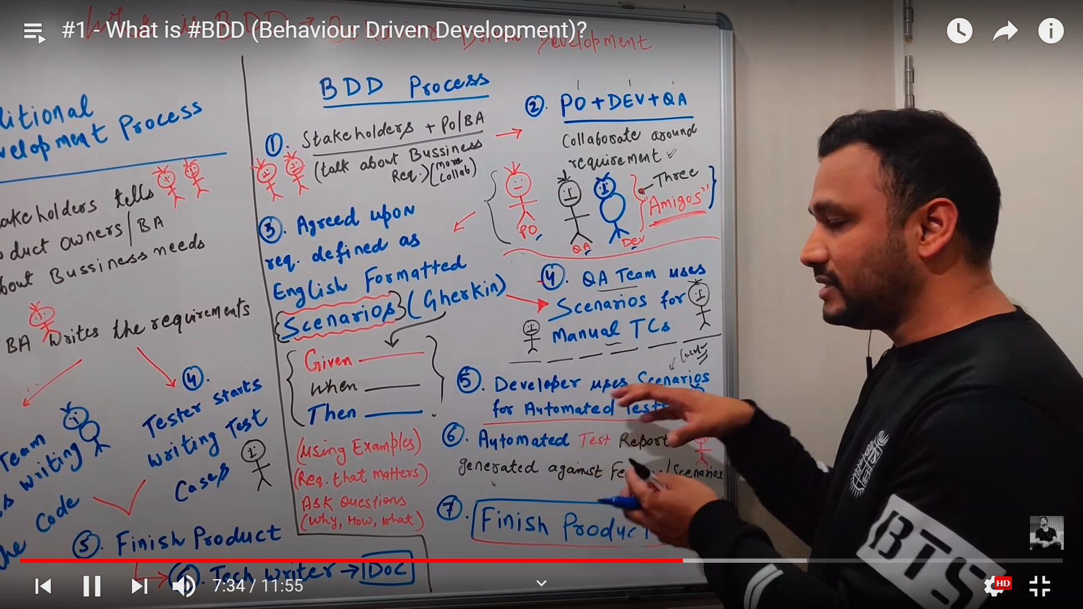

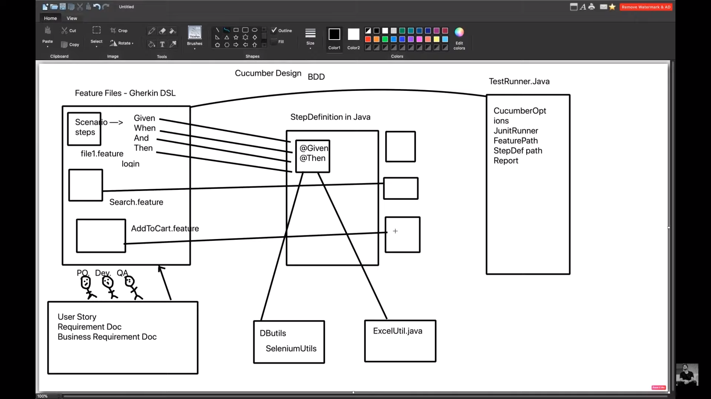

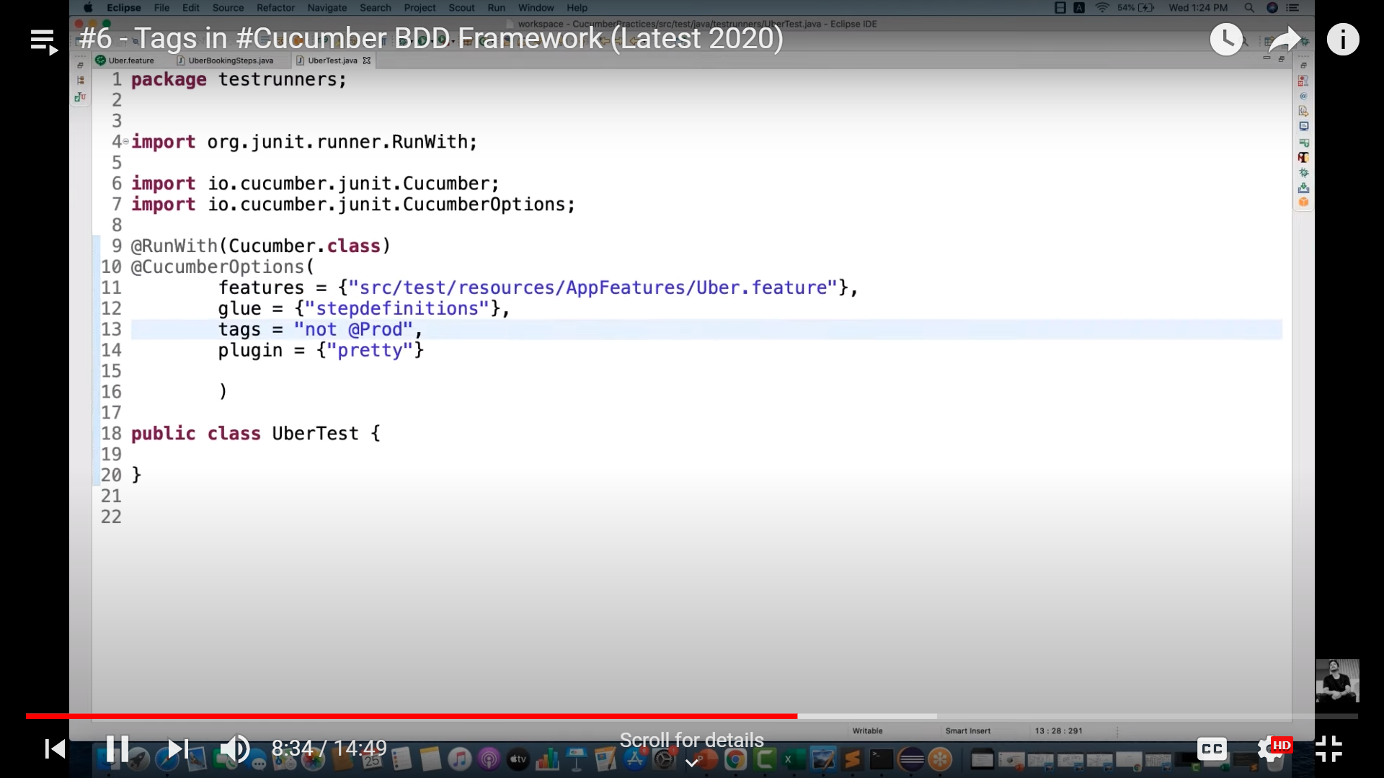

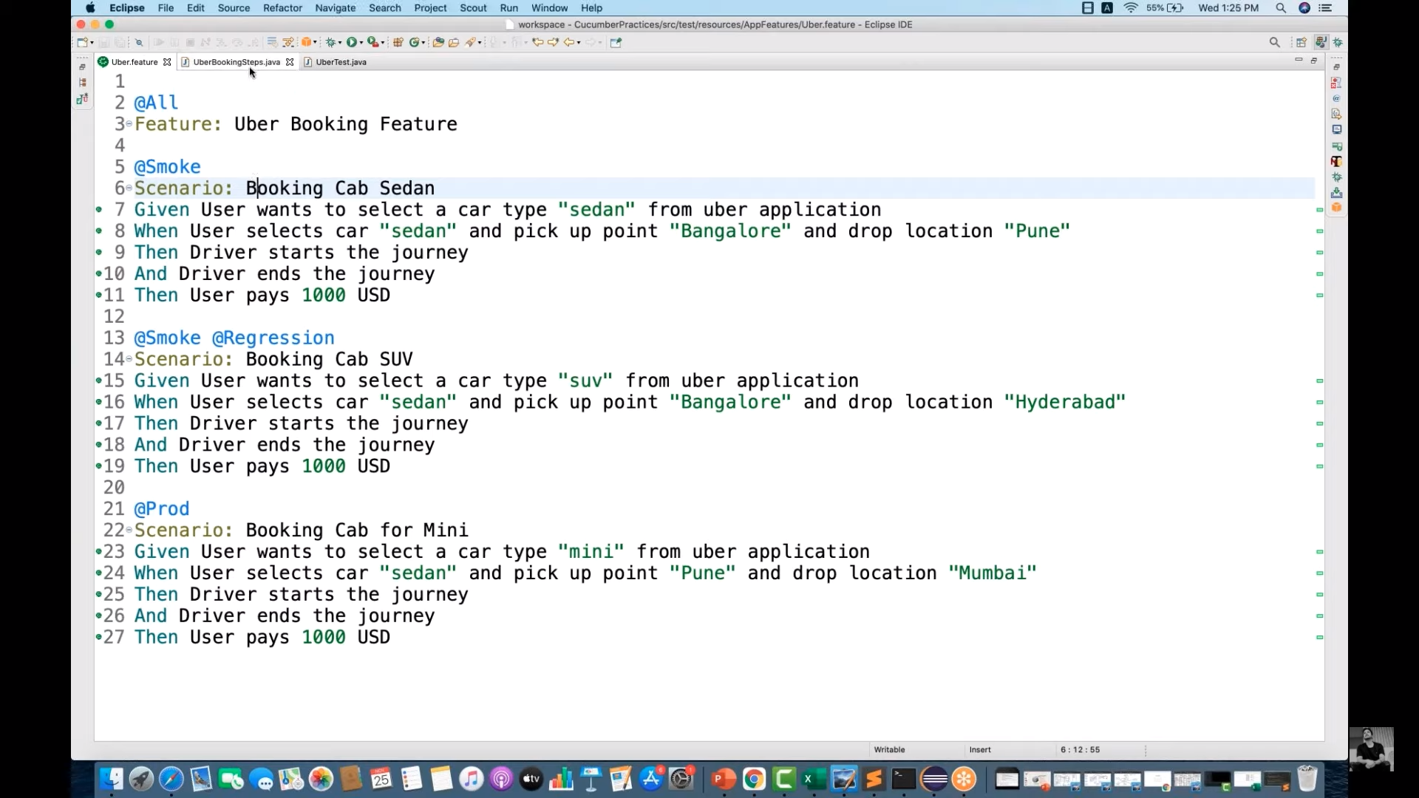

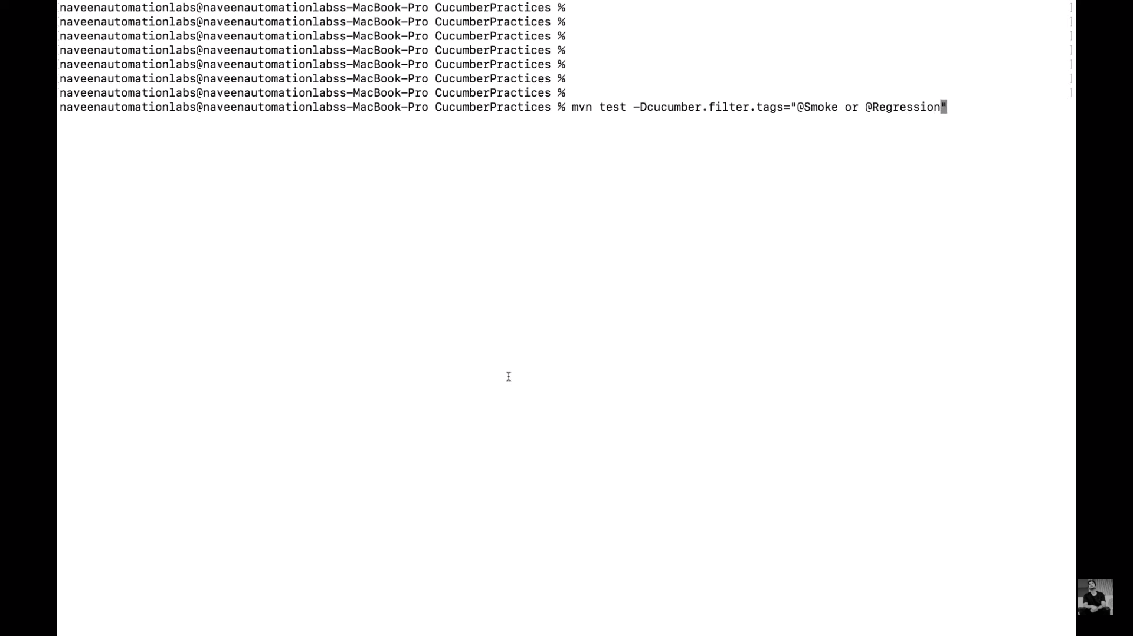

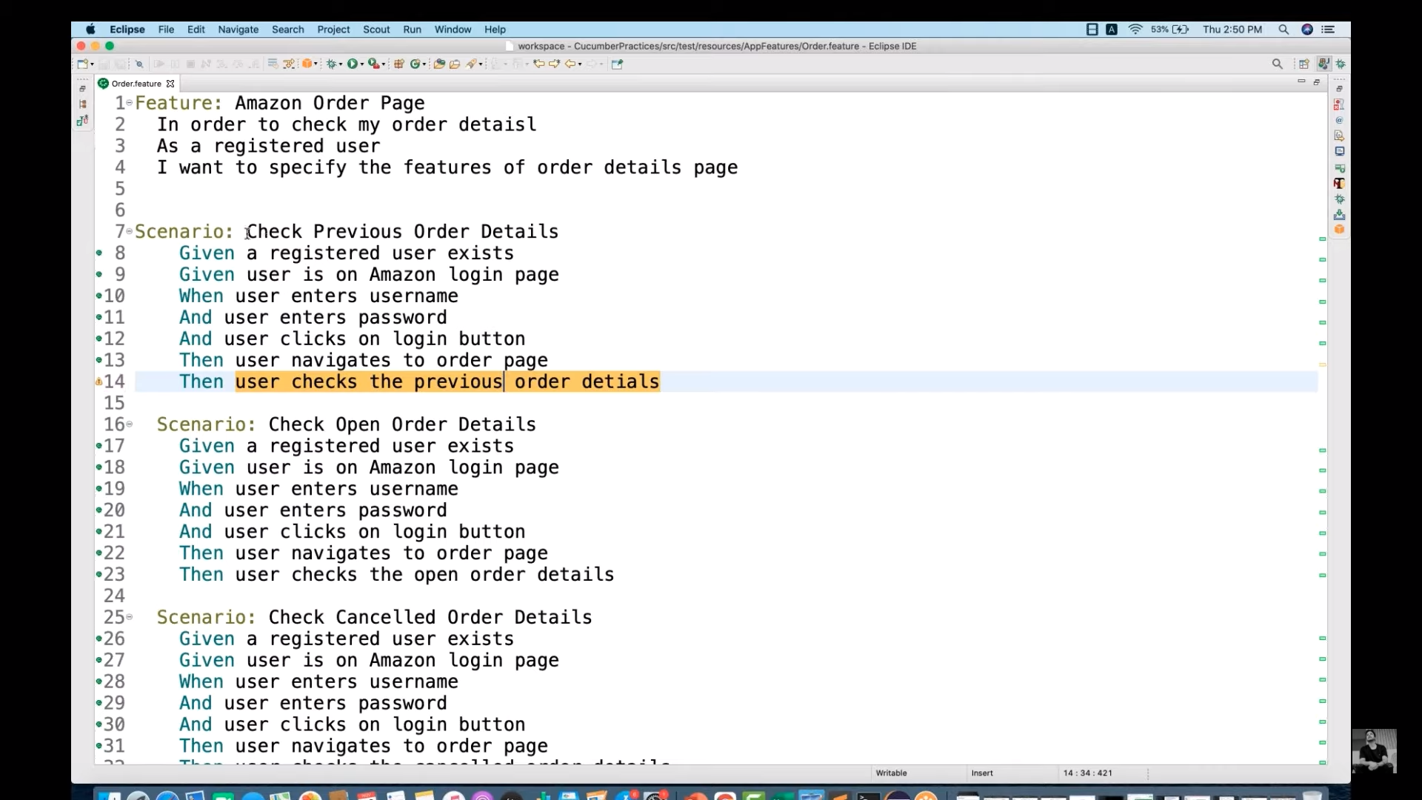

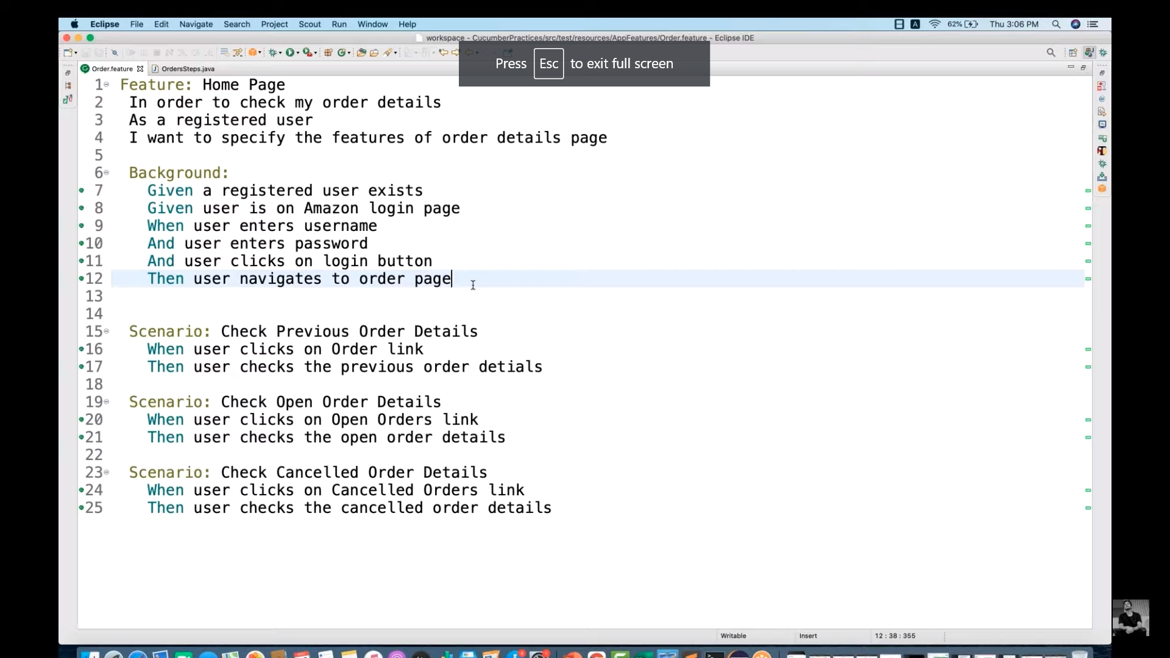

**#Author:**[**your.email@your.domain.com**](mailto:your.email@your.domain.com) **#Keywords Summary :  
#Feature: List of scenarios.  
#Scenario: Business rule through list of steps with arguments.  
#Given: Some precondition step  
#When: Some key actions  
#Then: To observe outcomes or validation  
#And,But: To enumerate more Given,When,Then steps  
#Scenario Outline: List of steps for data-driven as an Examples and <placeholder>  
#Examples: Container for s table  
#Background: List of steps run before each of the scenarios  
#""" (Doc Strings)  
#| (Data Tables)  
#@ (Tags/Labels):To group Scenarios  
#<> (placeholder)  
#""  
## (Comments)  
#Sample Feature Definition Template**

**Scenario:**

Given user navigates to Facebook

When I enter correct username and password

Then login should be successful

**Scenario:**

Given user navigates to Facebook

When I enter correct email address and password

Then login should be successful

**Scenario:**

Given user navigates to Facebook

When I enter correct phone number and password

Then login should be successful

Here, if we see closely, for above three scenarios: statements are the same, only the input parameter (username/email address/phone number) is changing. That’s where the importance of scenario outline comes into picture.

When we define any scenario with scenario outline, we can specify one test scenario and at the bottom of it we can provide a number of inputs. The scenario will get executed as many times as the number of inputs provided.

Scenario Outline: Billing Amount

Given user is billing page

When user enters billing amount "<billingamount>"

When user enters tax amount "<taxamount>"

And user clicks on calculate button

Then it should give final amount "<finalamount>"

Examples:

|billingamount | taxamount | finalamount|

|10000 | 10000 | 20000 |

|20000 | 20000 | 40000 |

